Phase I and Phase II Results – California (CA)

A. Introduction

Similar to other states with a high-foreclosure rate, California has also experienced an extended housing slump. For one, a few indicators show that the homeowner quality has been poor.
- Pre-foreclosures have jumped by a high 80% in the first quarter of 2009, signaling that another wave of foreclosures may be coming. Recently, the temporary freeze on foreclosures, or moratoriums, in California was lifted, catapulting foreclosure numbers higher in March. The latest data shows that foreclosures earlier in the quarter were suppressed, and the end of moratoriums is allowing lenders, like Fannie Mae and Freddie Mac, to clamp down on the mortgages.

- In addition to pre-foreclosures, the delinquency rate has also been on the rise. In some areas of California, delinquency on homeowner associations has reached almost 15%. The effects of delinquencies are cyclic, as homeowner associations provide employment to those in the community.

- In California, the effects of the housing downturn have started to move to previously unaffected areas. During the first quarter of 2009, there were around 315,000 default notices, a 80% increase from the previous quarter. Notices of default have increased to around 35% in some major cities, like San Francisco and Los Angeles. This is another signal of poor homeowner quality affecting California.

In addition to the homeowner quality, the general economic downturn has affected the housing market. New home construction is at a 25-year low, signaling lack of confidence in the real estate market. The unemployment rate is currently around 11.2%, one of the highest in the nation, which slows the road to recovery.

While the current climate of California’s real estate market may be grim, the future outlook is mixed. There are signs the California is on its way to an eventual recovery.
- The first quarter of 2009 showed an increase of 64% in sales of existing single-family homes, as compared to the same period last quarter. This is coupled with the fact that median home prices are on the rise month-over-month, for the first time since August of 2007.

- At the federal level, legislation has been passed to provide an $8,000 tax credit to first-time home buyers for homes purchased between January and November of 2009. Additionally, the state of California has passed legislation allowing a state tax credit of $10,000, on or after March 1, 2009. The particular legislation, Senate Bill 15, has the potential of helping over 10,000 buyers purchase new homes. The tax credits act as stimulus for potential homebuyers, and an increase in home construction will stabilize the housing prices.
- Reflecting the federal and state tax credits, the homebuilder sales rose around 15% in the West part of California. The increase in homebuilder sales is also a sign of recovery.

However, even with certain signs of recovery, there are reasons for continued concerns. As mentioned earlier, the ending of moratoriums by Fannie and Freddie has increased the number of foreclosures and pre-foreclosure notices. This could outweigh the signs of recovery, as well as the existing tax breaks obtained from legislation. In addition, the unemployment rate mentioned earlier is still high, which may delay housing-market recovery and add even more foreclosures. Furthermore, some critics of the tax credit legislations say that the tax credits discourage purchases of existing foreclosed homes. There are many available homes that have been foreclosed, but the tax credits only apply to purchases of new homes.

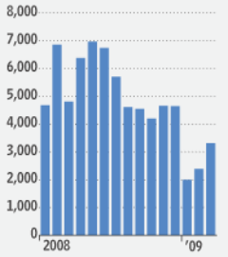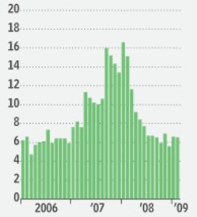
Figure I.1: Total residual permits issued in California (left); Months needed to sell existing inventory at current sales prices (right)

Looking at Figure I.1, the left plot shows that during the 1st quarter of 2009, there has been an increase in housing construction. However, that is juxtaposed with the figure on the right, which shows that the months needed to sell existing inventory has been stable for the past few months. This exhibits that the while construction has been rising, housing inventory has remained stable, which provides support for critics of housing tax credits.

B. Plot of Lagged Predictors vs. HPI (simple returns)
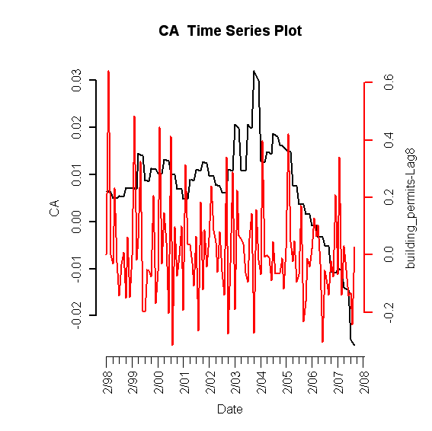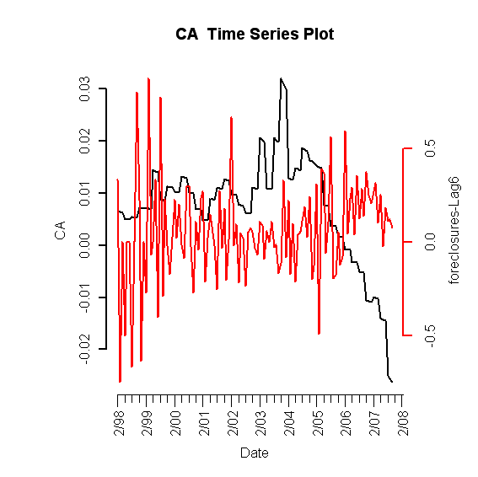
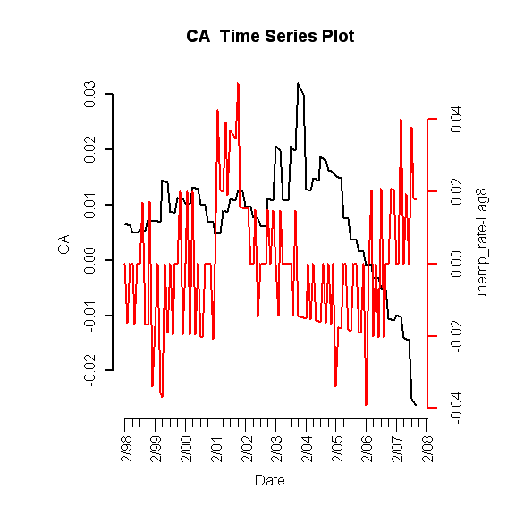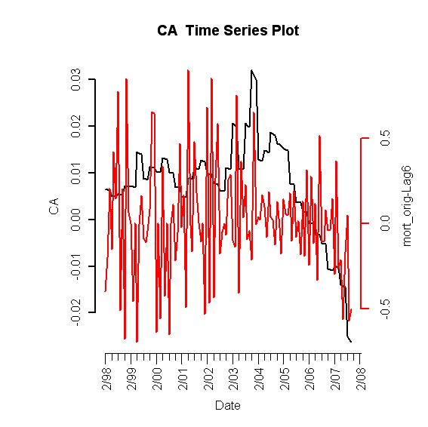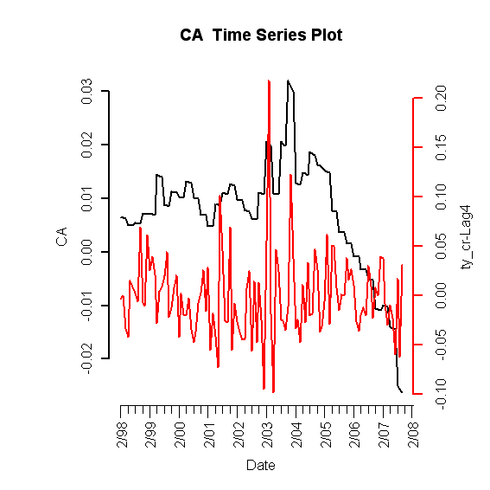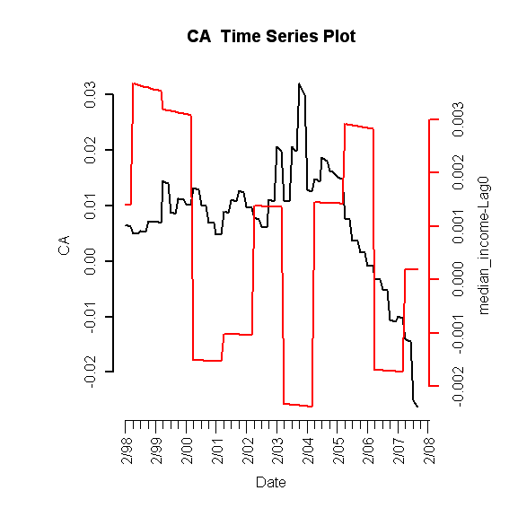

Figure I.2: Lagged predictors vs. Idaho HPI

C. Final Multivariate Model

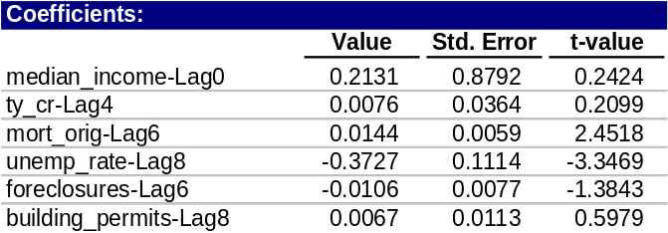
Table 1: Fitted drift model

1. Phase I: Drift Model

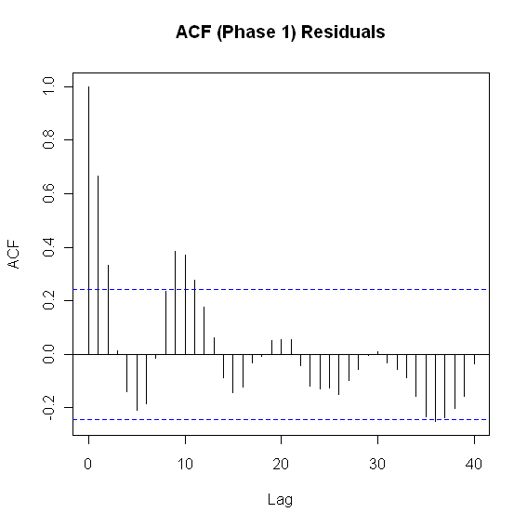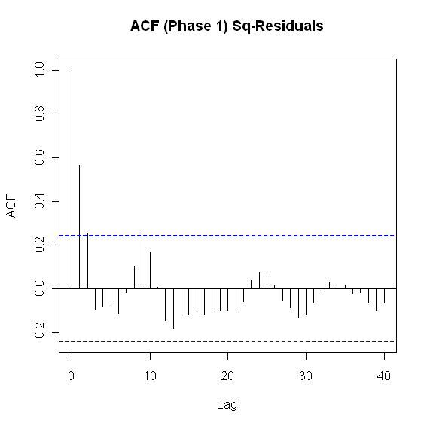
Figure I.3: ACF of residuals (left) and squared residuals (right) of fitted linear model

2. Phase II: Volatility Model

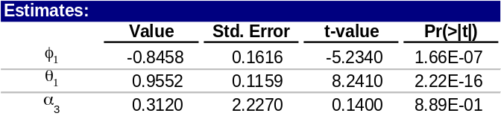
Table 2: California fitted volatility model

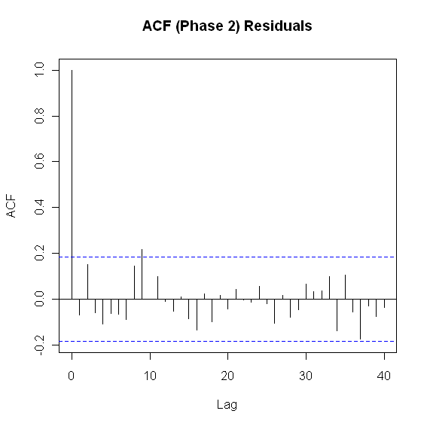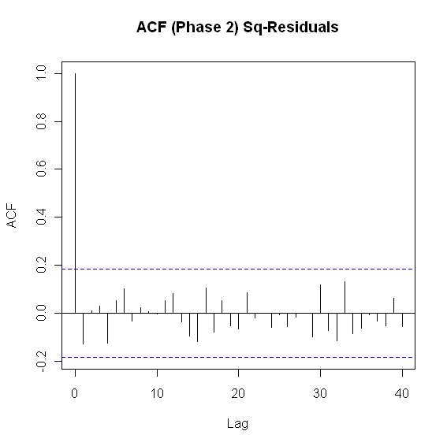
Figure I.4: ACF of residuals (left) and squared residuals (right) of the Phase II model for California

3. Model Checking Diagnostics

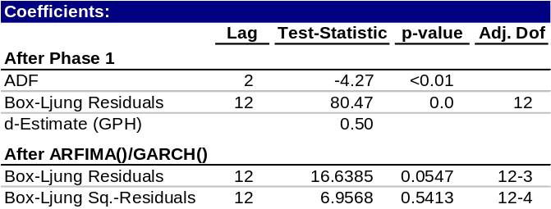
Table 3: Statistical test results for complete model

D. Fitted vs. Actual Plots

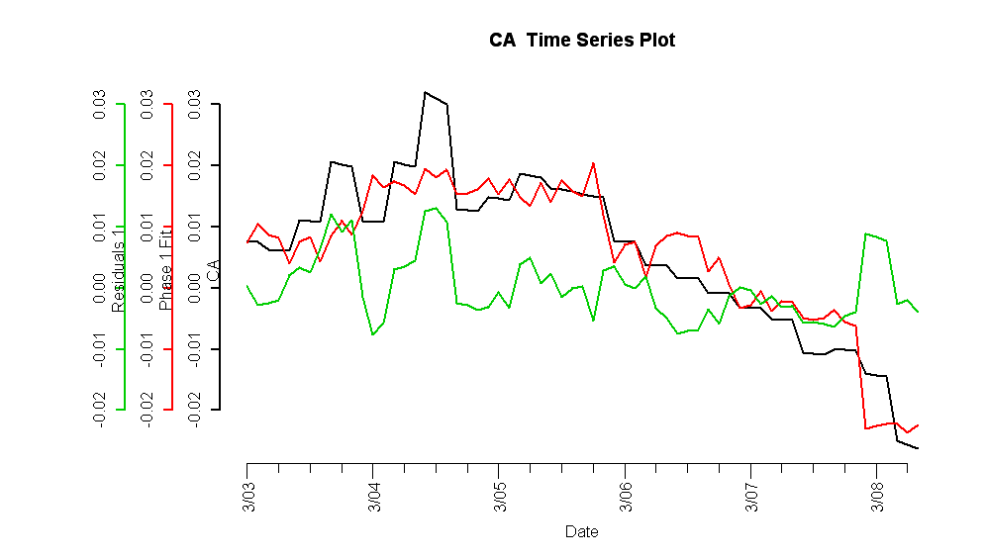
Figure I.5: Fitted Phase I vs. California HPI (red) and residuals (green)

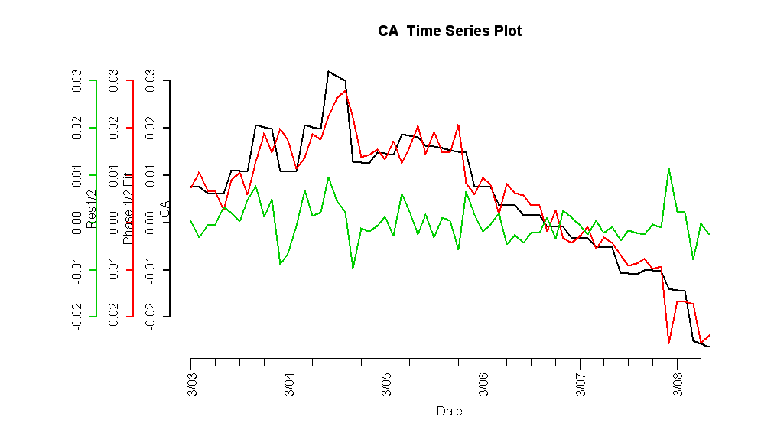

Figure I.6: Complete fitted model vs. California HPI (top) and residuals (bottom)

E. Forecasts
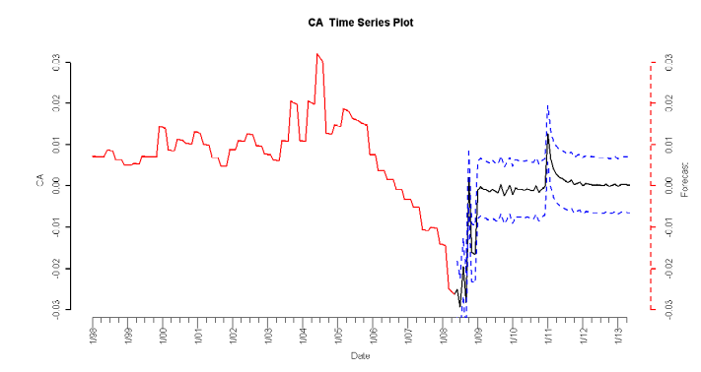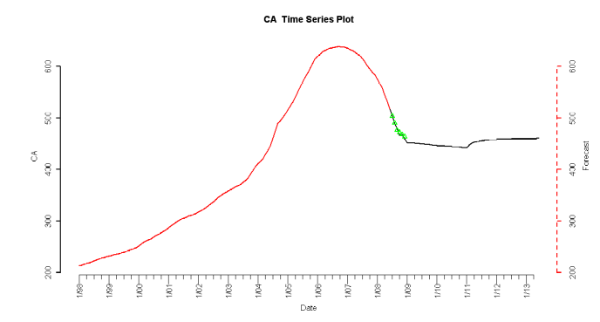
Figure I.7: 5-year forecasted simple returns (top) and forecasted HPI (bottom)

F. Interpretation of Forecasts

As seen in the simple return plot on top of Figure I.7, the simple return remains in negative territory until mid 2009, and then hovers around the zero mark. At around the beginning of 2011, the simple returns begin to increase above the zero line. Similarly, in the actual HPI forecasts, the HPI is projected to decrease after 2008, but the rate of decrease is slowed. The forecasts show that by 2011, the HPI has a reversal and begins a slow upward trend.

The forecasts seem in line with the current outlook of California. As mentioned, there are signs of recovery but at the same time, presently, there are still continued concerns. With the unemployment rate and the increasing foreclosures, the housing market downturn is still taking its toll on the state. This is reflected in the continued decrease of the HPI. However, the rate of decrease is dropping, which indicates that there may be signs of a change. With the tax credit as well as increase in single-family homes, California is on its road to a slow recovery. By 2011, the model predicts that there is ultimately a turnaround.

